MARIAL CHOL AGUDI
BSCCS/2024/48971
ETHICAL HACKING / CYBERSECURITY
UNIT CODE: BIT4139
SUDOTICKET AND DVWA ()
KALI LINUX (WSL2) + DOCKER DESKTOP
DATE: 3RD JUNE 2026
MICHAEL NYOR
YEAR:4.1
Ethical Hacking Assessment and Security Analysis

Selected Technologies
Kali Linux, Nmap
Whois, Dig
Curl ,theHarvester
Docker, DVWA

Contents
WEEK 1 4
WEB VULNERABILLITY SCANNING 4
WEEK 2 5
DNS FOOTPRINTING 5
PORT SCANNING 6
WEEK 3 7
Fig 1: WhatWeb is sudoticket.com. 7
WEEK 4 7
Fig 2: IP Address (dig sudoticket.com) 7
Fig 3: Technologies: [web server, framework] 8
Fig 4: email patterns 8
Fig 5: nmap -sV www.sudoticket.com Port and Service Discovery 9
Fig 5: Network service enumeration results. 9
Fig 6: sql injection 10
Tools I used 11

WEEK 1

WEB VULNERABILLITY SCANNING
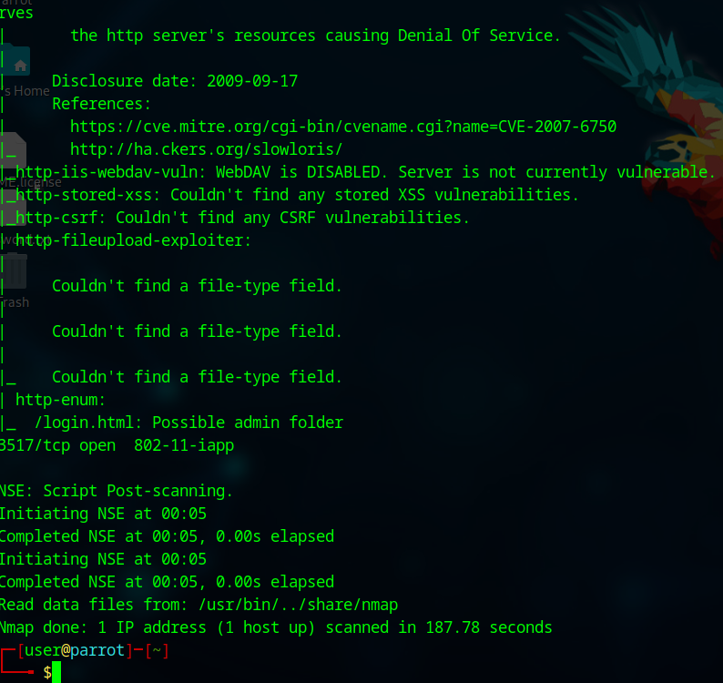

WEEK 2

DNS FOOTPRINTING
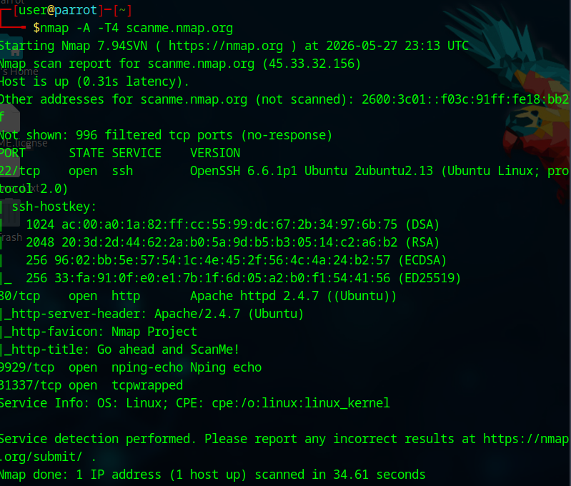

PORT SCANNING
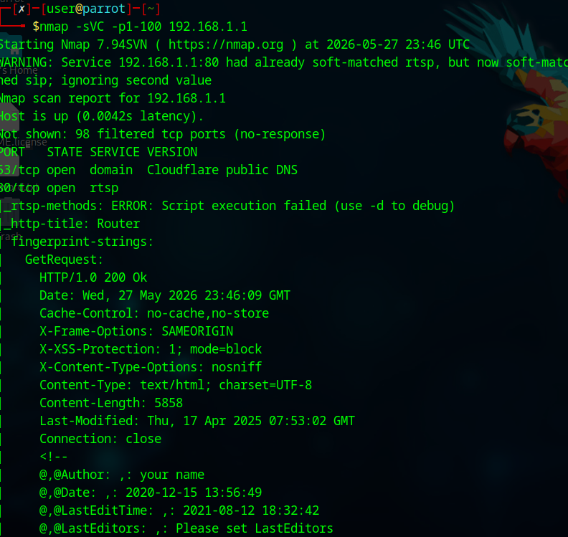

WEEK 3

Fig 1: WhatWeb is sudoticket.com.
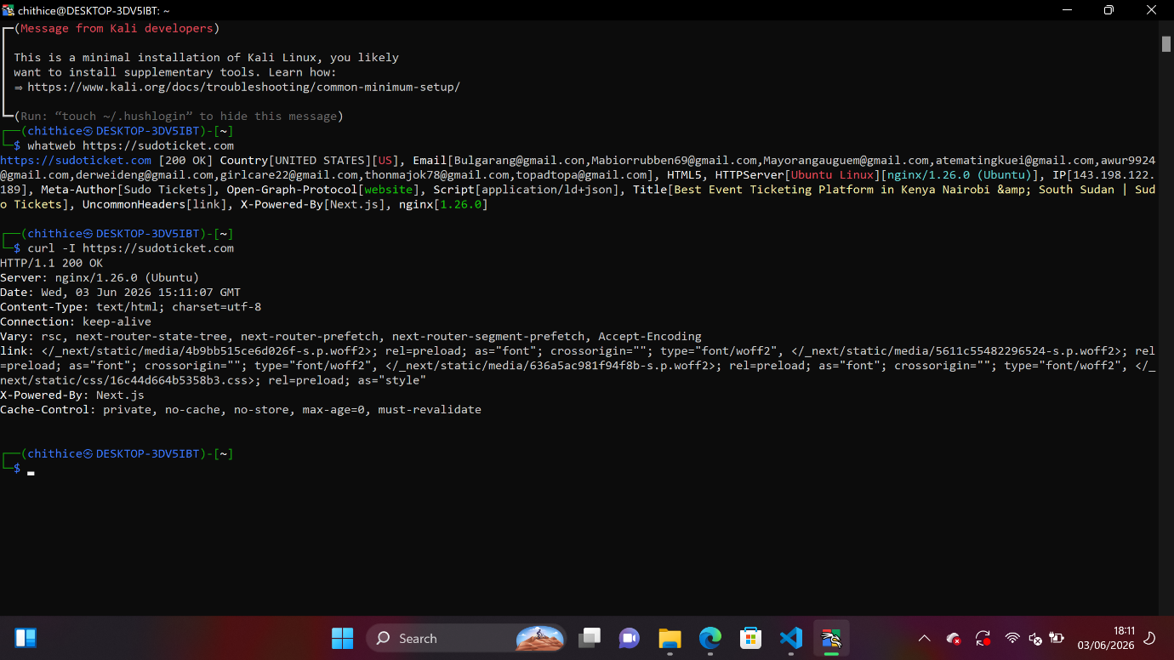

WEEK 4

Fig 2: IP Address (dig sudoticket.com)

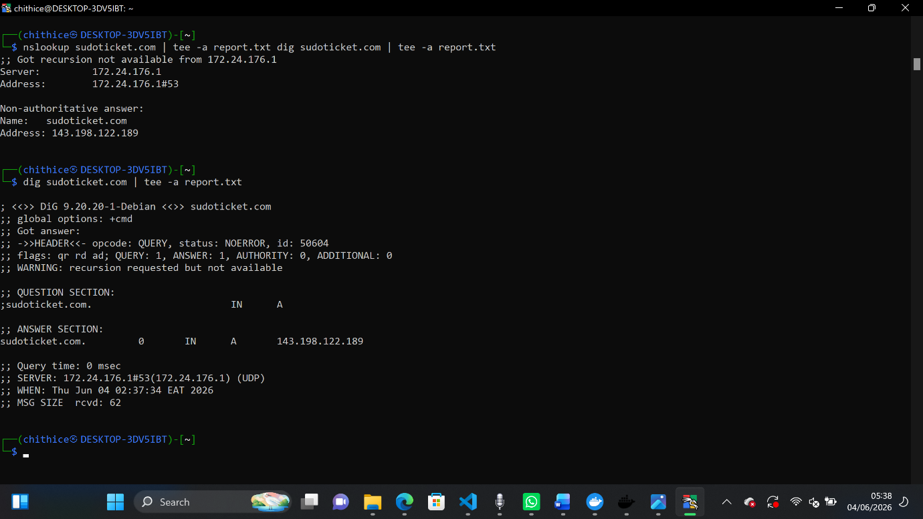

Fig 3: Technologies: [web server, framework]
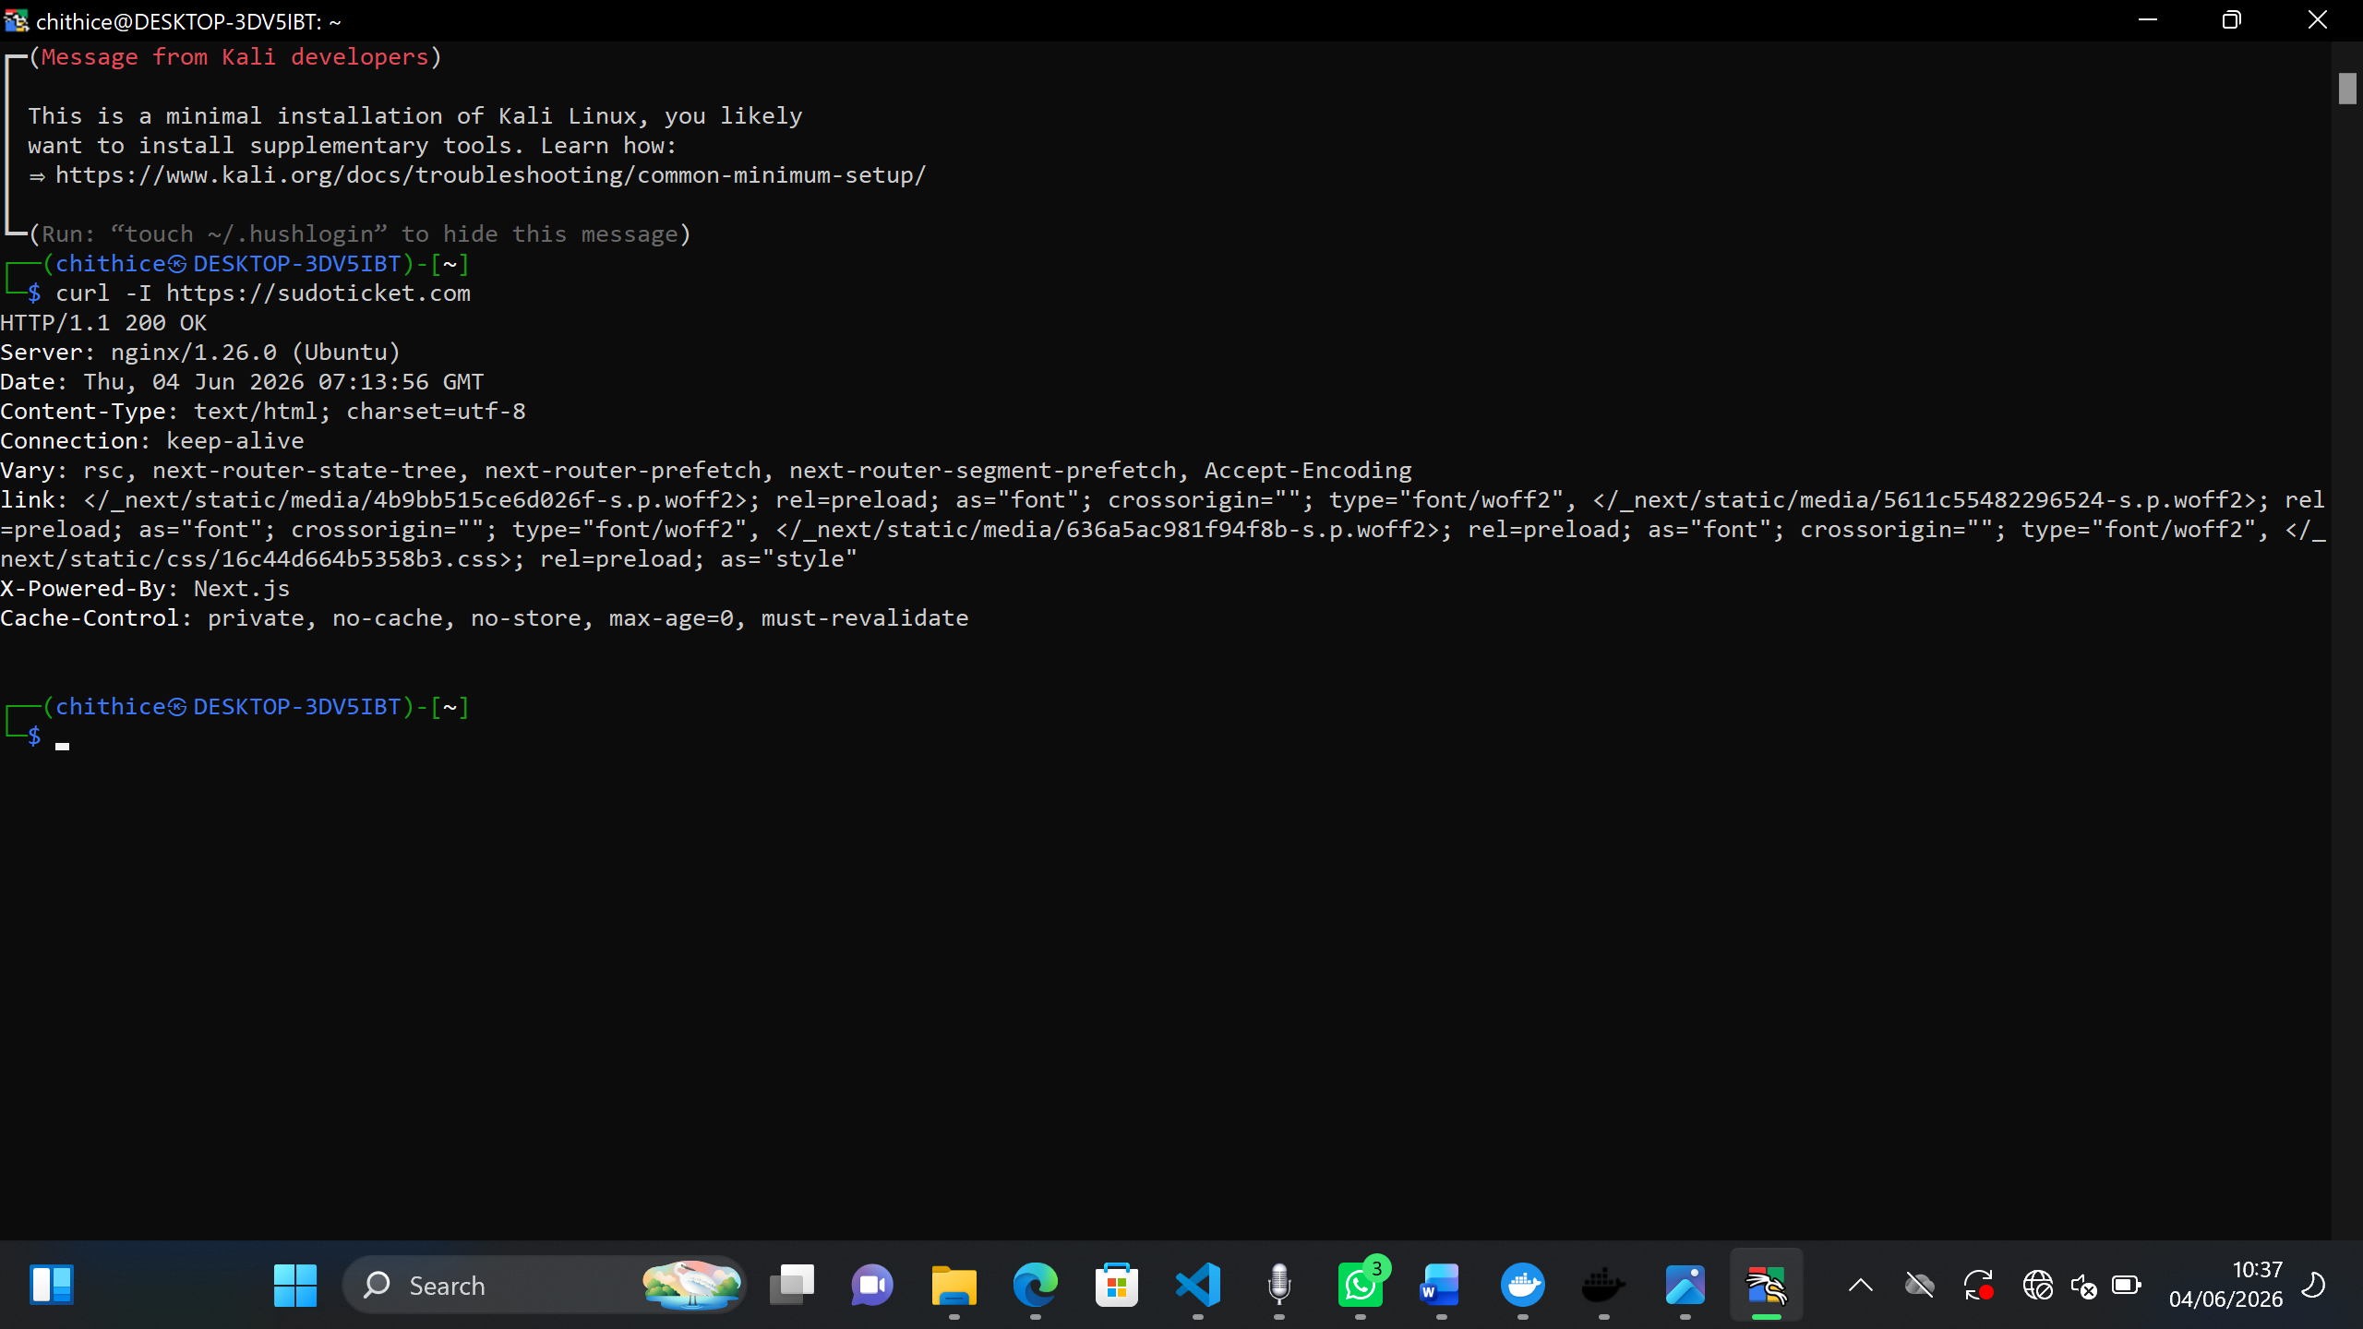

Fig 4: email patterns
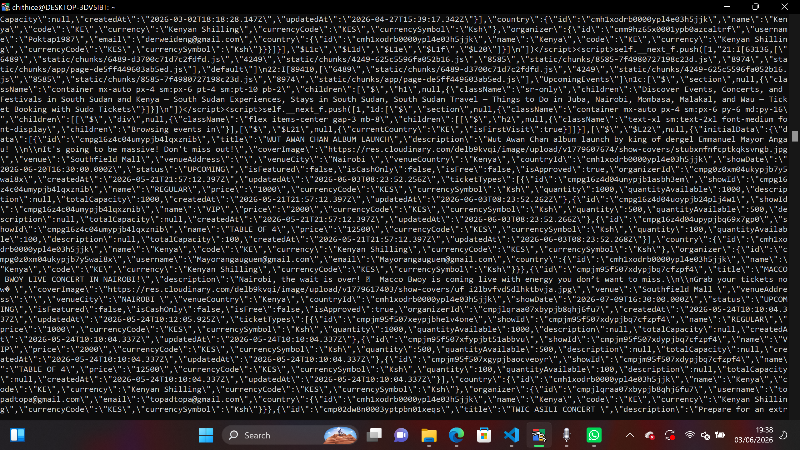

Fig 5: nmap -sV www.sudoticket.com Port and Service Discovery
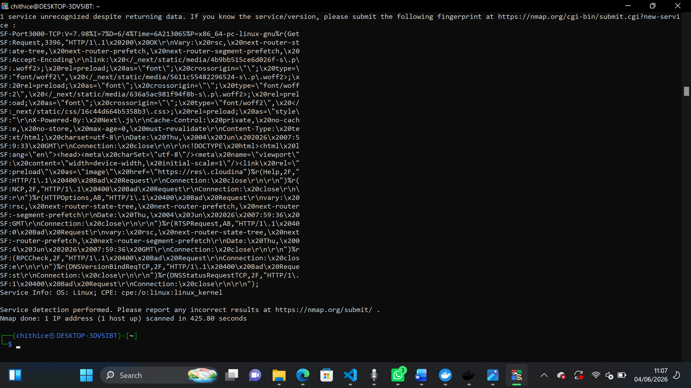
Fig 5: Network service enumeration results.
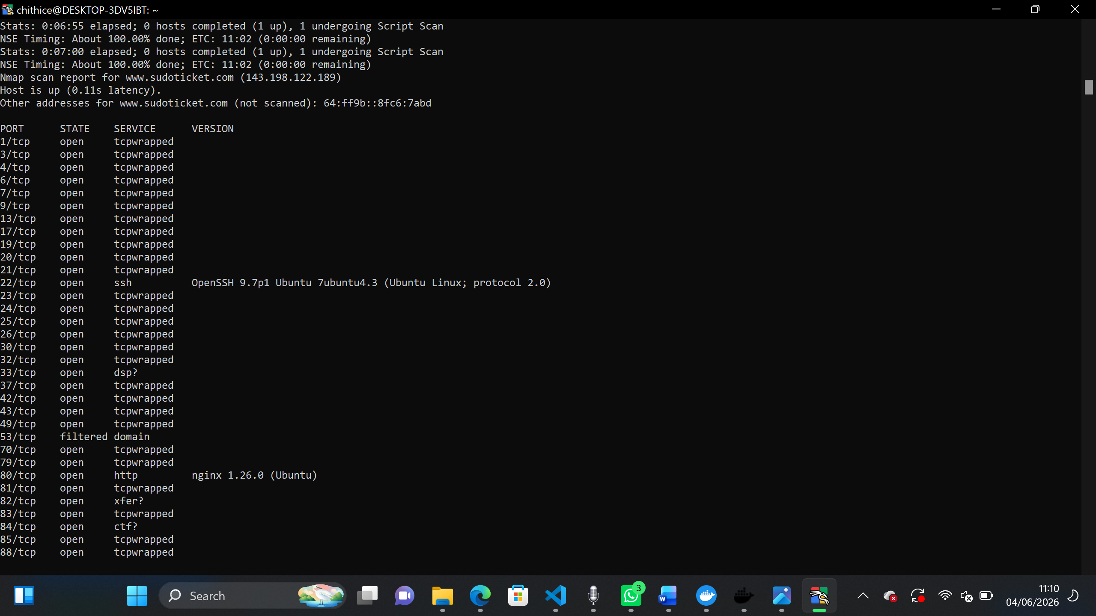

Fig 6: sql injection
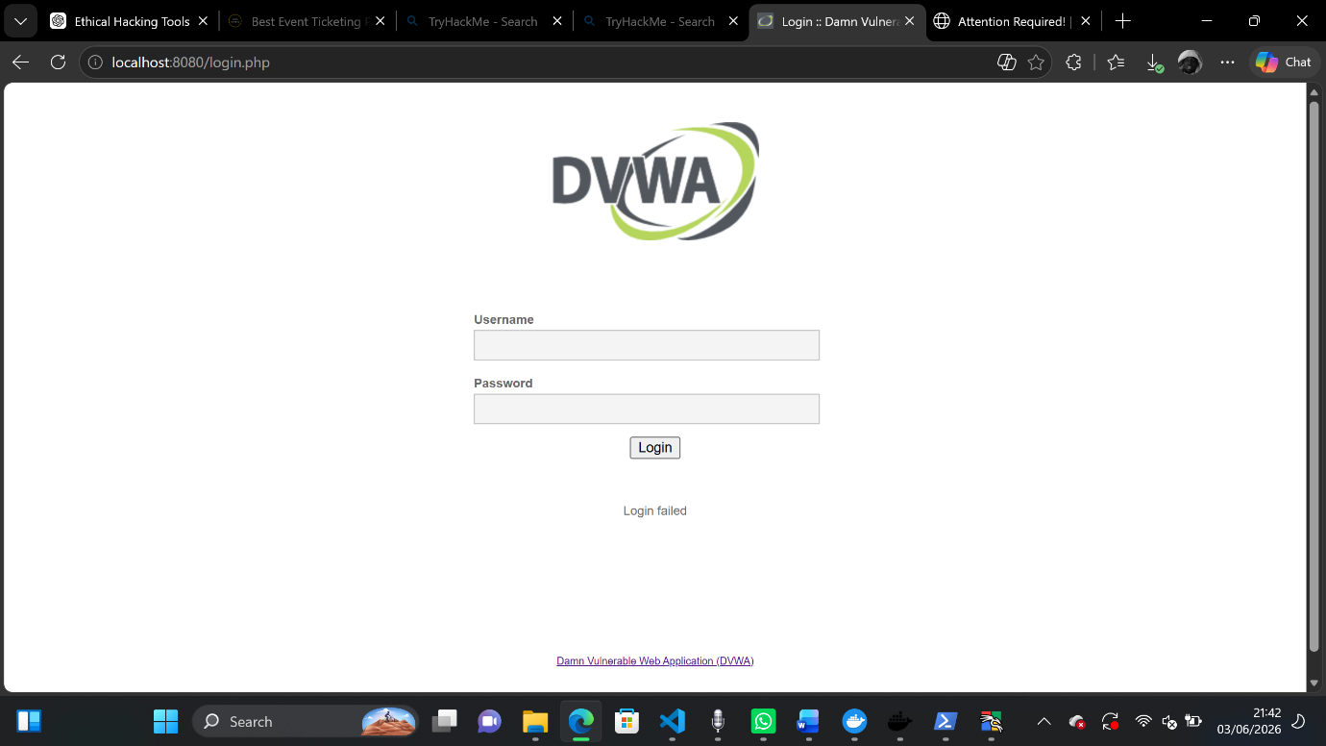

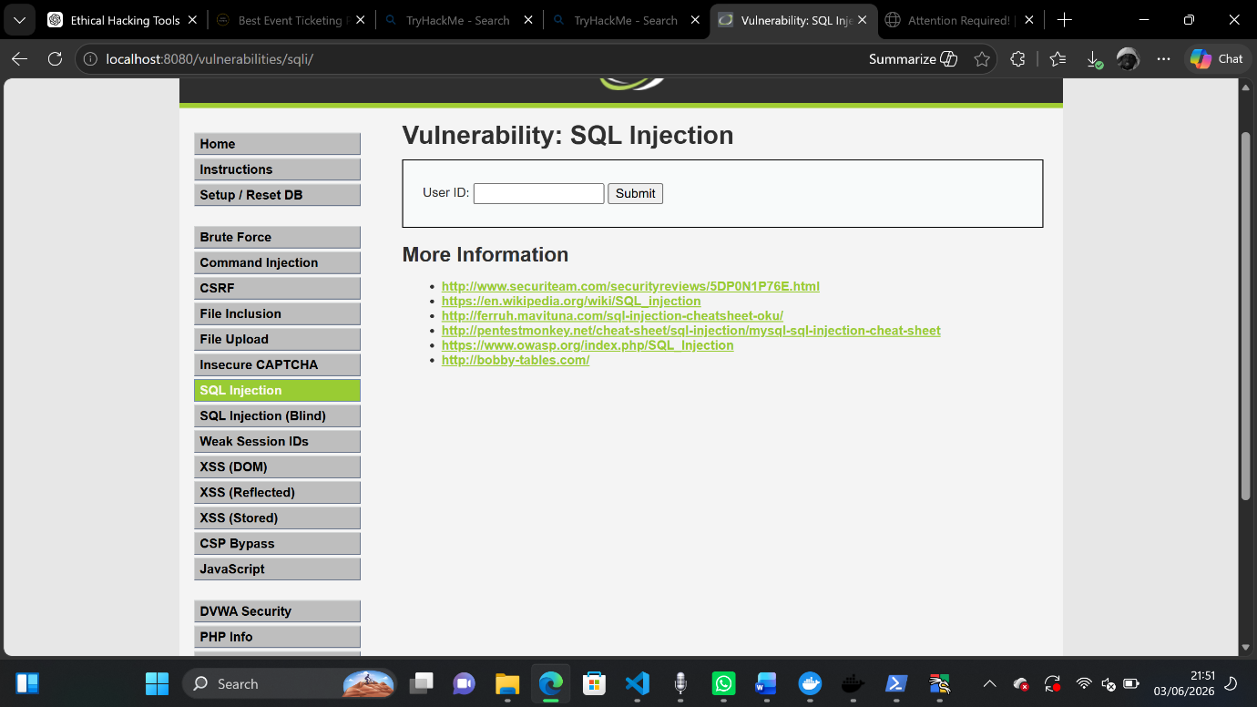

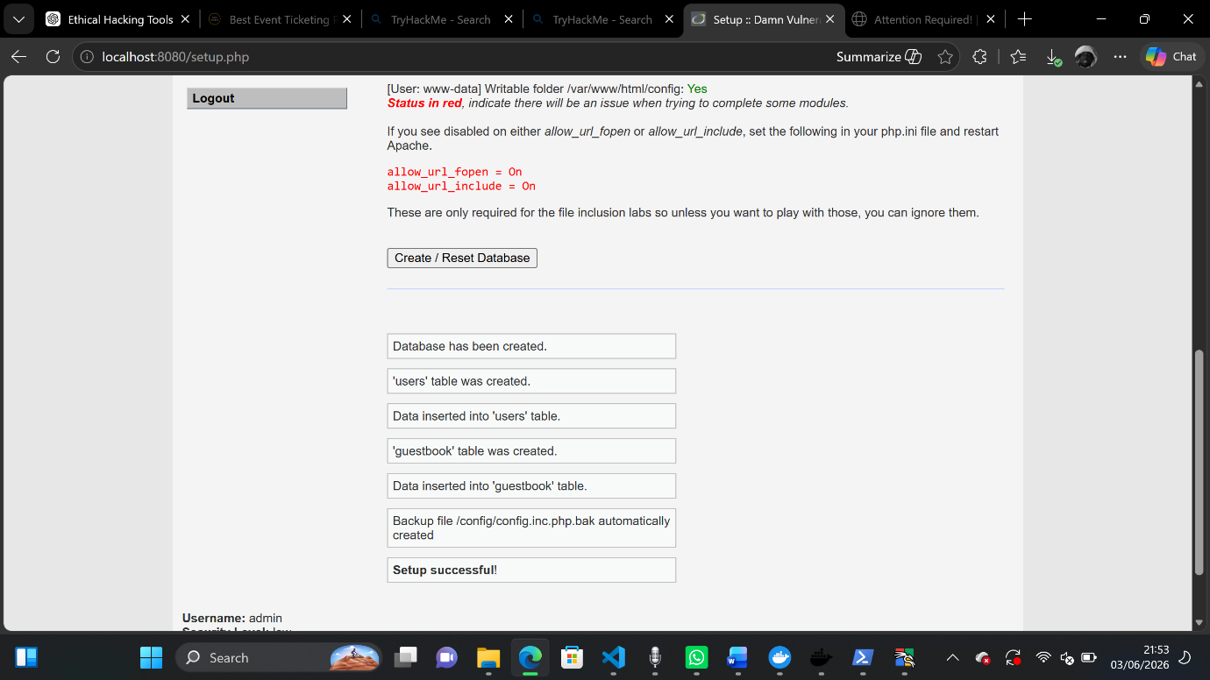

SQL Injection testing was conducted on DVWA because it is a controlled vulnerable environment. SudoTicket was assessed only through safe reconnaissance and configuration review.

Tools I used
- Nmap
- Nikto
- theHarvester
- Whois
- sqlmap
- Curl
- unAUTHORIZATION
- Target: sudoticket.com
- Scope: SQL Injection Testing Only
- Date: [date]
- Permission: unauthorization
EOF

